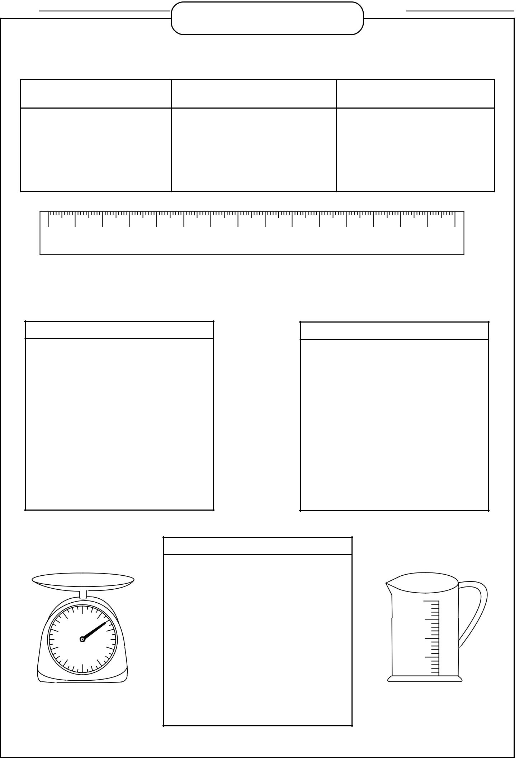
Name : |  |  |  |  |  |  |  |  |  |  |  |  |  | Date :
 |  |  |  |  |  | UNIT CONVERSION CHART
 |  |  |  |  | Commonly Used Metric Unit Conversion
 | Length and Distance |  |  |  |  |  |  |  | Weight |  |  |  |  |  | Capacity
10 millimeter = 1 centimeter |  |  |  |  |  |  | 1000 gram = 1 kilogram |  |  |  |  |  |  | 1000 milliliter = 1 liter
100 centimeter = 1 meter |  |  |  |  |  | 1000 kilogram = 1 metric ton |  |  |  |  |  |  |  |  | 1000 liter = 1kiloliter
1000 meter = 1 kilometer
0 | 1 |  | 2 | 3 | 4 | 5 | 6 | 7 | 8 | 9 | 10 |  | 11 | 12 | 13 | 14 | 15
 | cm
 |  |  |  |  |  | Complete Metric Unit Conversion
 | Length and Distance |  |  |  |  |  |  |  |  |  |  |  |  | Weight
 | 10 millimeter = 1 centimeter |  |  |  |  |  |  |  |  |  |  |  | 10 milligram = 1 centigram
 | 10 centimeter = 1 decimeter |  |  |  |  |  |  |  |  |  |  | 10 centigram = 1 decigram
 | 10 decimeter = 1 meter |  |  |  |  |  |  |  |  |  |  |  | 10 decigram = 1 gram
 | 10 meter = 1 dekameter |  |  |  |  |  |  |  |  |  |  |  | 10 gram = 1 dekagram
 | 10 dekameter = 1 hectometer |  |  |  |  |  |  |  |  |  |  | 10 dekagram = 1 hectogram
10 hectometer = 1 kilometer |  |  |  |  |  |  |  |  |  |  |  | 10 hectogram = 1 kilogram
 |  |  |  |  |  |  |  | Capacity
 |  |  |  |  |  |  | 10 milliliter = 1 cent
 |  |  |  |  |  |  | 10 centiliter = 1 deciliter |  |  |  |  |  |  |  |  | mL
 |  |  |  |  |  |  |  |  |  |  |  |  |  |  |  | 1000
 | 9 | 0 | 1 |  |  |  |  |  |  |  |  |  |  |  |  | 750
 |  | kg |  |  |  |  | 10 deciliter = 1 liter
 | 8 |  |  | 2
 |  |  |  |  |  |  |  |  |  |  |  |  |  |  |  | 500
 | 7 |  |  | 3 |  |  |  | 10 liter = 1 dekaliter
 | 6 | 5 | 4 |  |  |  |  |  |  |  |  |  |  |  |  | 250
 |  |  |  |  |  |  | 10 dekaliter = 1 hectoliter
 |  |  |  |  |  | 10 hectoliter = 1 kiloliter

